SKILL BASED JOB

RECOMMENDER

APPLICATION

|  |  |
| --- | --- |
| **DATE** | **3-NOV-22** |
| **TEAM ID** | **PNT2022TMID22144** |
| **PROJECT NAME** | **Skill Based Job Recommender Application** |
| **MAXIMUM MARK** | **4 Marks** |

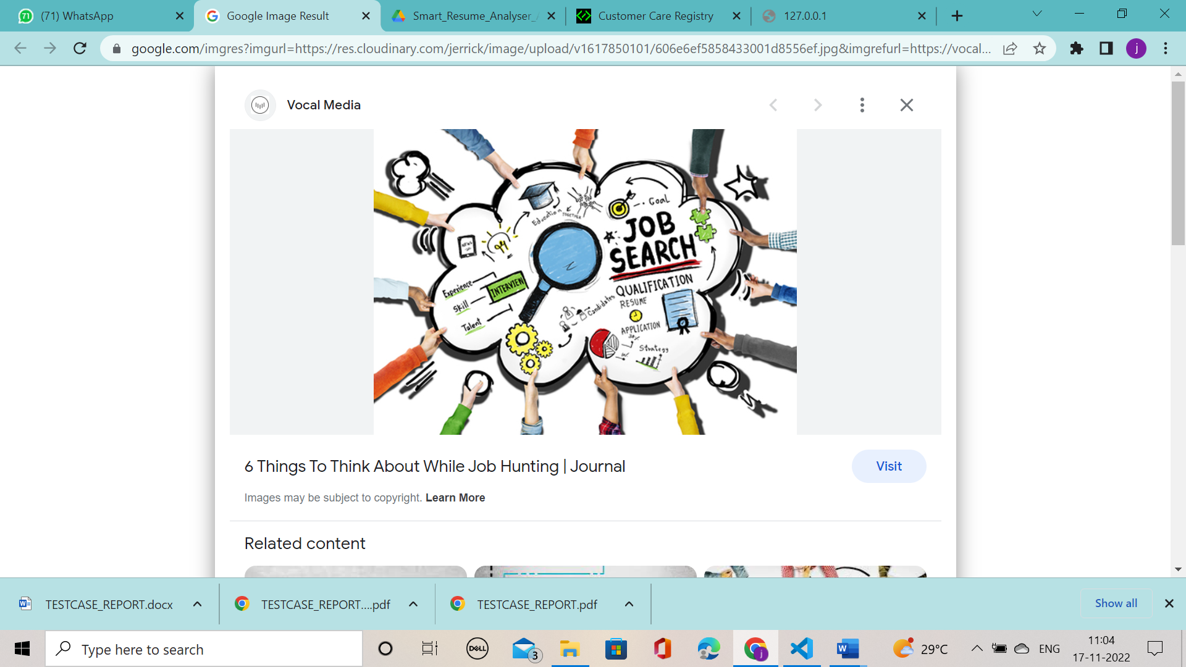

**TEST CASE REPORT**

|  |  |  |  |  |  |  |  |  |  |  |  |
| --- | --- | --- | --- | --- | --- | --- | --- | --- | --- | --- | --- |
| **Test case** | **Feature Type** | **Component** | **Test Scenario** | **Steps To Execute** | **Expected Result** | **Actual Result** | **Status** | **Comments** | **TC for**  **Automation(Y/ N)** | **BUG ID** | **Executed By** |
| Login page | Functional | Home Page | Verify user is able to see the Login/Signup | 1. Enter URL and click go 2. Scroll down   3.Verify login/Signup page | Login/Signup popup should display | Working as expected | PASS | Successful | Y |  | NIRANJANA M  HARITHA VELLAM T |
| Login Page | UI | Home Page | Verify the UI elements in Login/Signup page | 1.Enter URL and click go 2. Click on Signup page for User  3.Verify login/Sign up popup with below UI elements:  a. Id text box  b. Password text box  c. Login button | Application should show below UI elements:  a. Email text box  b. password text box | Working as expected | PASS | Successful | Y |  | JUNEHA JABEEN A  KRISHIKHA R |
| Login Page | Functional | Home page | Verify user is able to log into application with Valid credentials | 1.Enter URL and click go  2.Click on login page drop down   1. Enter Valid ID in text box 2. Enter valid password in password text box   5. Click on login button | User should navigate to user information homepage | Working as expected | PASS | Successful | Y |  | NIRANJANA M  JUNEHA JABEEN A |

|  |  |  |  |  |  |  |  |  |  |  |  |
| --- | --- | --- | --- | --- | --- | --- | --- | --- | --- | --- | --- |
| Login Page | Functional | Login page | Verify user is able to log into application with Invalid credentials | 1.Enter and click go  2. Click on login dropdown button  3.Enter Invalid ID in ID text box  4.Enter valid password in password text box  5. Click on login button | Application should show 'Incorrect email or password ' validation message. | Working as expected | PASS | Successful | Y |  | HARITHA VELLAM T  KRISHIKHA R |
| Login Page | Functional | Login page | Verify user is able to log into application with In Valid credentials | 1.Enter URL() and click go  2.Click on My Account dropdown button   1. Enter Valid ID in ID text box 2. Enter Invalid password in password text box 5.Click on login button | Application should show 'Incorrect email or password ' validation message. | Working as expected | PASS | Successful | Y |  | NIRANJANA M  JUNEHA JABEEN A |
| Login Page | Functional | Login page | Verify User is able to log into application with Valid Credentials | 1.Enter URL  and click go 2.Click on Sign in page  3.Enter In Valid ID in ID text box  4.Enter Invalid password in password text box 5.Click on login button | Application should show 'correct email or password ' validation message. | Working as expected | PASS | Successful | Y |  | KRISHIKHA R  HARITHA VELLAM T |

|  |  |  |  |  |  |  |  |  |  |  |  |
| --- | --- | --- | --- | --- | --- | --- | --- | --- | --- | --- | --- |
| Login Page | Functional | Login page for ADMIN | Verify User is able to log into application with Valid Credentials | 1.Enter URL  and click go 2.Click on Sign in page  3.Enter In Valid ID in ID text box  4.Enter Invalid password in password text box 5.Click on login button | Application should show 'correct email or password ' validation message. | Working as expected | PASS | Successful | Y |  | JUNEHA JABEEN A  NIRANJANA M |
| Login Page | UI | Home page for USER | Verify user is able to see the User home page when user finish on submitting Credentials | 1.Enter UR  and click go 2.Click on sign in button   1. Enter Valid ID in ID text box 2. Enter valid password in password text box 5.Click on login button | USER Home Page  Should display the sign in page | Working as expected | PASS | Successful | Y |  | HARITHA VELLAM T  KRISHIKHA R |
| Login Page | UI | ADMIN PAGE | On delete Button the user Credentials will be deleted | 1.Enter UR  and click go 2.Click on sign in button 3.Enter In Valid ID in ID text box  4.Enter Invalid password in password text box 5.Click on login button | ADMIN Home page should the sign in page | Working as expected | PASS | Successful | Y |  | JUNEHA JABEEN A  HARITHA VELLAM T |

|  |  |  |  |  |  |  |  |  |  |  |  |
| --- | --- | --- | --- | --- | --- | --- | --- | --- | --- | --- | --- |
| **Test case ID** | **Feature Type** | **Component** | **Test Scenario** | **Steps To Execute** | **Expected Result** | **Actual Result** | **Status** | **Comments** | **TC for**  **Automation (Y/N)** | **BUG ID** | **Executed By** |
| User Page | Functional | USER PAGE | Verify user is able to search the job based on their skills | 1.Enter URL and click go 2.Scroll down  3.Verify login/Sign up displayed or not | Show search box | Working as expected | PASS | Successful | Y |  | NIRANJANA M  HARITHA VELLAM T |
| User Page | UI | USER PAGE | Verify the User whether their identify the job based on their skill | Click on the URL and go to user page by giving Correct Credentials | Display the job recommendation | Working as expected | PASS | Successful | Y |  | JUNEHA JABEEN A  KRISHIKHA R |
| User Page | UI | USER PAGE | Verify User | Click on the URL and go to user page by giving Correct Credentials | Display the job recommendation | Working as expected | PASS | Successful | Y |  | NIRANJANA M  JUNEHA JABEEN A |

|  |  |  |  |  |  |  |  |  |  |  |  |
| --- | --- | --- | --- | --- | --- | --- | --- | --- | --- | --- | --- |
| Admin Page | Functional | Admin Page | Admin can see the user database | 1.Enter URL  : and click go 2.Enter the Credentials for the admin page and submit | user database should display on admin page | Working as expected | PASS | Successful | Y |  | KRISHIKHA R  HARITHA VELLAM T |
|  |  |  |  | 1.Enter URL | Detect the user Database | Working as expected | PASS | Successful | Y |  | NIRANJANA M  JUNEHA JABEEN A |
| Admin Page | Functional | Admin Page | Admin can detect the user Database | and click go 2.Click on submit by giving correct credentials to the admin Page |
|
|  |  |  |  | 1.Enter URL | Detect the job recommendation. | Working as expected | PASS | Successful | Y |  | KRISHIKHA R  HARITHA VELLAM T |
| Admin Page | Functional | Admin Page | Verify the overall search and will get a job recommendation | and click go 2.Click on submit by giving correct credentials to the admin Page  3.After type the skills will get recommendation |
|

|  |  |  |  |  |  |  |  |  |  |  |  |
| --- | --- | --- | --- | --- | --- | --- | --- | --- | --- | --- | --- |
| **Test case ID** | **Feature Type** | **Component** | **Test Scenario** | **Steps To Execute** | **Expected Result** | **Actual Result** | **Status** | **Comments** | **TC for**  **Automation(Y/**  **N)** | **BUG ID** | **Executed By** |
| Home Page | Functional | Home Page | Verify user is able to see the Login/Signup page when user clicked the left corner button | 1. Enter URL and click go 2.Scroll down 3.Verify login/Sign up page displayed or not | Login/Signup page should display | Working as expected | PASS | Successful | Y |  | NIRANJANA M  JUNEHA JABEEN A |
| Home Page | UI | Home Page | Verify the UI elements in Login/Signup page | 1.Enter URL and click go 2.Click on Sign in button for User  3.Verify login/Sign up popup with below UI elements:  a.id text box  b. Password text box | Application should show below UI elements:  a .email text box b. password text box c. login page will display | Working as expected | PASS | Successful | Y |  | KRISHIKHA R  HARITHA VELLAM T |
| Home Page | Functional | Home page | Verify user is able to log into application with Valid credentials | 1.Enter URL and click go 2.Click on My Account  dropdown button   1. Enter Valid ID in ID text box 2. Enter valid password in password text box 5.Click on login button | User should navigate to user homepage | Working as expected | PASS | Successful | Y |  | JUNEHA JABEEN A  HARITHA VELLAM T |

|  |  |  |  |  |  |  |  |  |  |  |  |
| --- | --- | --- | --- | --- | --- | --- | --- | --- | --- | --- | --- |
| **Test case ID** | **Feature Type** | **Component** | **Test Scenario** | **Steps To Execute** | **Expected Result** | **Actual Result** | **Status** | **Comments** | **TC for**  **Automation(Y/**  **N)** | **BUG ID** | **Executed By** |
| Chat box | Functional | Chat box | Verify user is unable to login in the login page. | 1.Enter URL and click go  2.Scroll down 3.when you are login/Sign up in the page if their facing any issue you can use the chat | Chat box should display | Working as expected | PASS | Successful | Y |  | NIRANJANA M  HARITHA VELLAM T |
| Chat box | UI | Chat box | Verify the user is ask their query to chat box or not | 1.Enter URL and click go 2.Click on Signup button for User.   1. Create an account for the user 2. User will use the chat box | Chat box should display | Working as expected | PASS | Successful | Y |  | JUNEHA JABEEN A  KRISHIKHA R |
| Chat box | Functional | Chat box | Verify the user is able to chat with chat box assistant | 1.Enter URL and click go 2.Click on Signup button for User.   1. 3.Create an account for the user   4.User will use the chat box and get the reply from chat assistant | Application should  Chat with user | Working as expected | PASS | Successful | Y |  | HARITHA VELLAM T  JUNEHA JABEEN A |